**Data Analysis Project Report on   
Impact of Screen Time on University Students: An In-depth Analysis**

V.Saikrishna

**Introduction:** The widespread use of electronic devices such as smartphones, laptops, and televisions has led to increased screen time among individuals of all age groups. This study aims to investigate the effects of screen time on university students' daily routines, behaviors, and overall well-being. By collecting and analyzing data from a diverse group of students, this research seeks to uncover patterns and trends related to screen time and its associated impacts.

**Data Visualization:**

**Link for Dashboard:**

<https://public.tableau.com/views/Effectsofscreentimefinal/Dashboard1?:language=en-US&publish=yes&:display_count=n&:origin=viz_share_link>

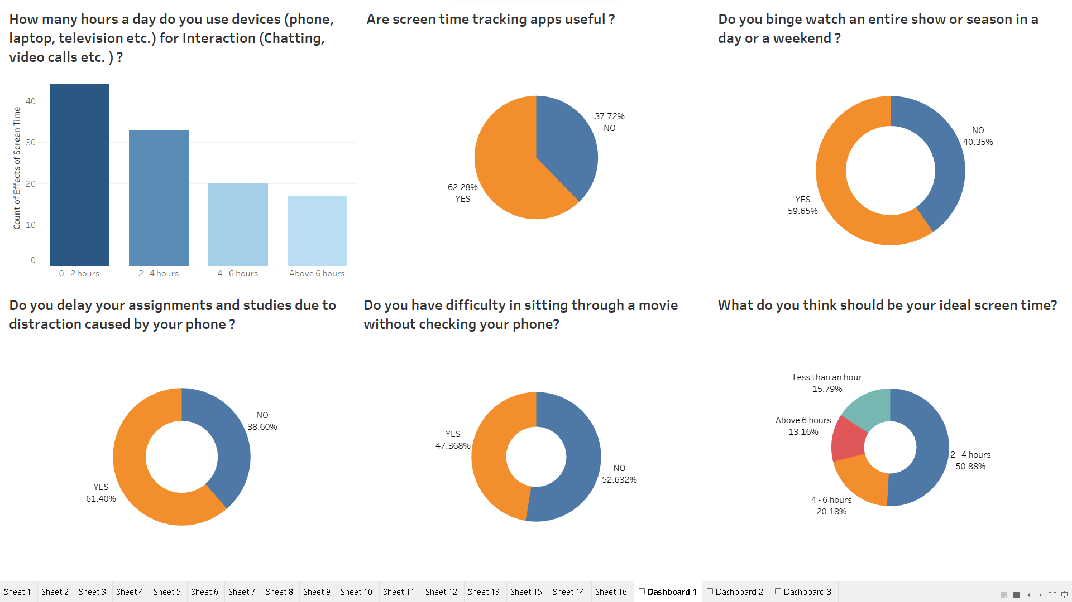

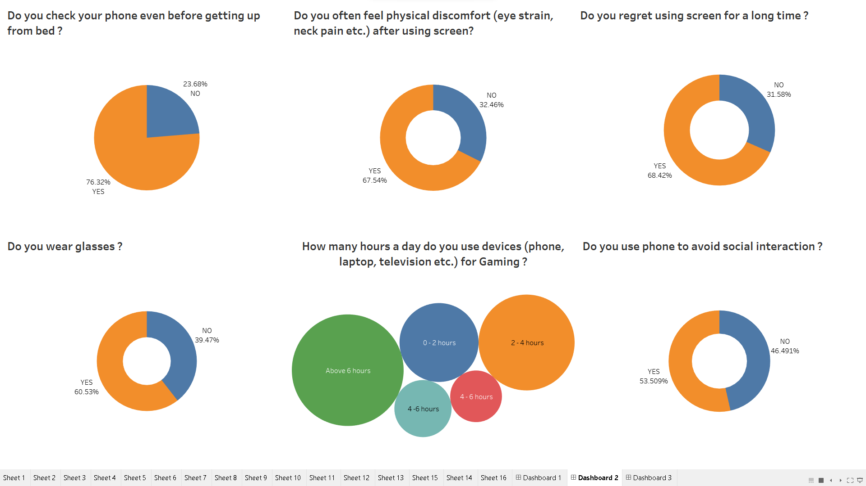

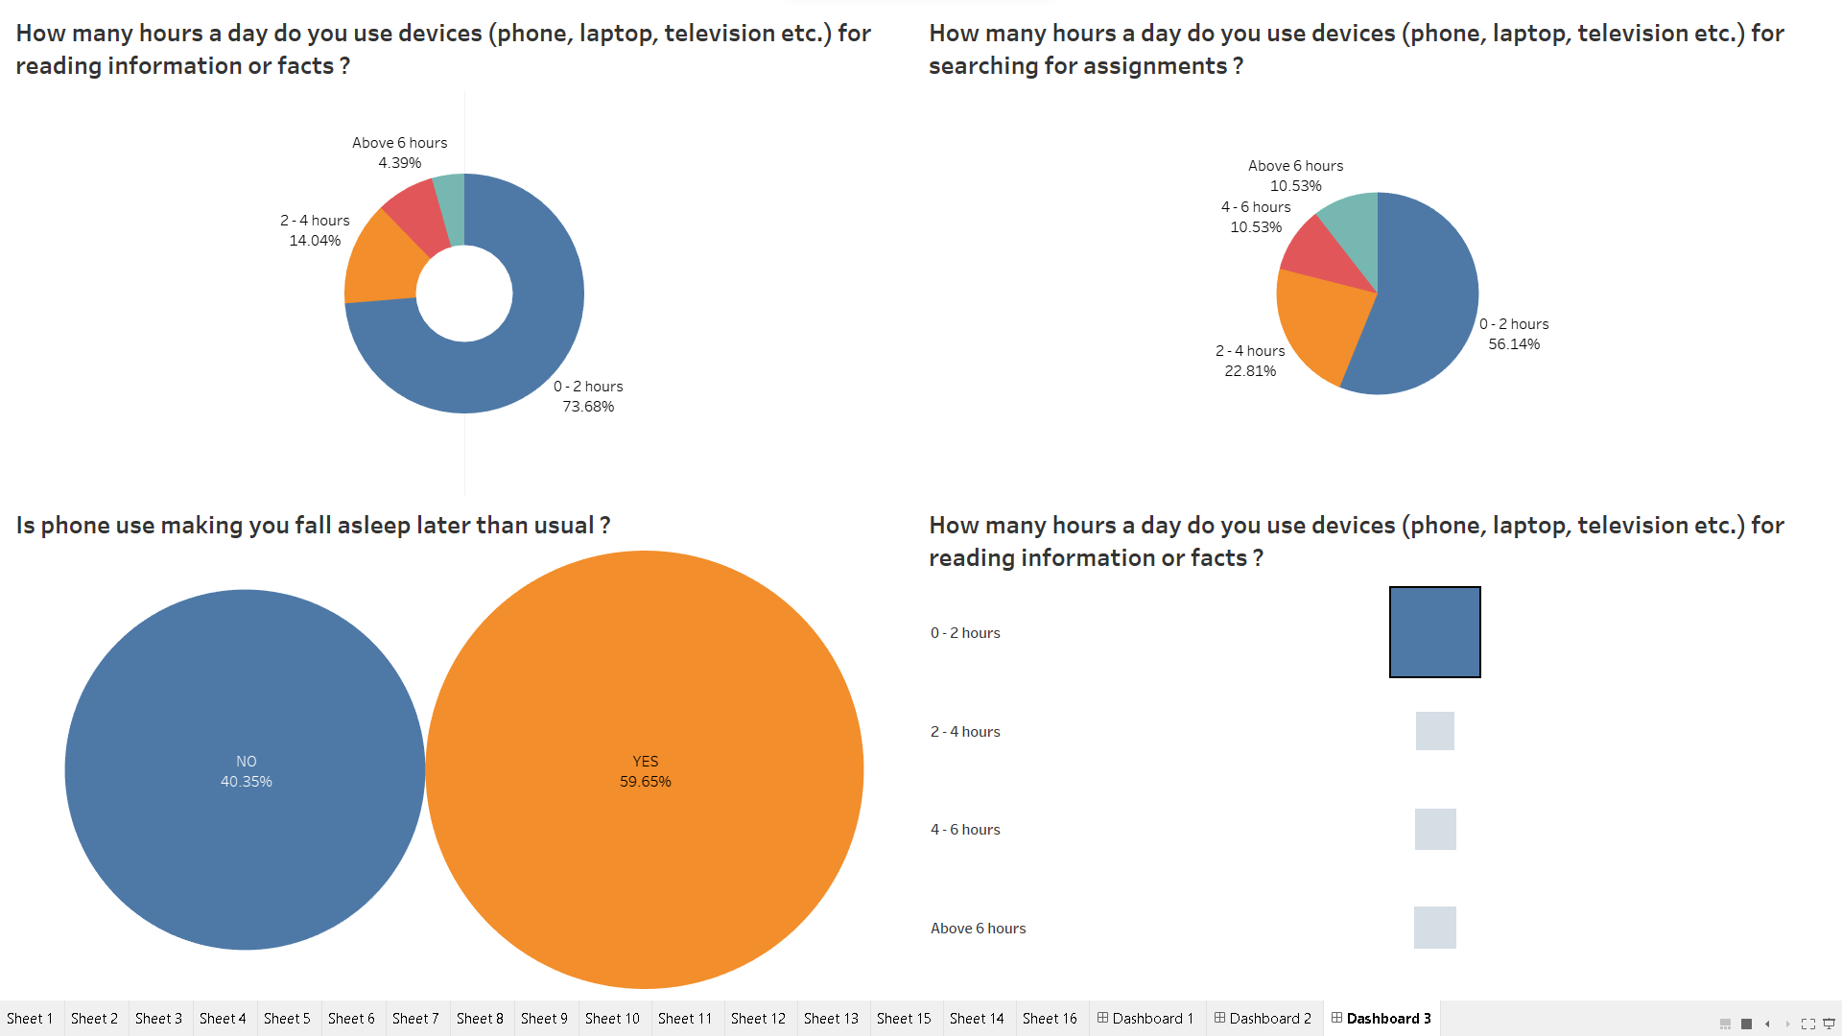

**Methodology:** Data for this analysis was collected through surveys distributed among university students. The survey consisted of questions pertaining to various aspects of screen time, including entertainment, interaction, academic activities, physical discomfort, and personal habits. The responses were recorded and stored in an Excel sheet, and further analysis was conducted using Tableau to visualize and derive meaningful insights.

**Findings:**

1. **Distribution of Screen Time for Different Activities:**
   * Entertainment: The majority of students reported spending a significant portion of their screen time on entertainment activities such as watching movies and reels.
   * Interaction: Students also indicated a considerable amount of time spent on interactions, including chatting and video calls.
   * Academic Tasks: Screen time for academic tasks like searching for assignments and reading information varied, with some students spending more time in these activities compared to others.
   * Gaming: A notable proportion of students engaged in gaming, contributing to their overall screen time.
2. **Physical Discomfort and Health Impact:**
   * A substantial number of students reported experiencing physical discomfort, including eye strain and neck pain, after prolonged screen usage.
   * A correlation was observed between high screen time and physical discomfort, suggesting the need for ergonomic practices.
3. **Social Interaction and Distraction:**
   * A significant fraction of students admitted to using their phones to avoid social interaction, potentially impacting their social relationships.
   * Many students acknowledged that phone usage led to delays in assignments and studies due to distraction.
4. **Screen Time Tracking and Regret:**
   * Students showed mixed opinions about the usefulness of screen time tracking apps in managing their device usage.
   * A notable percentage of students expressed regret over excessive screen time, indicating awareness of its negative consequences.
5. **Sleep Patterns and Ideal Screen Time:**
   * A correlation was found between late-night phone use and disrupted sleep patterns, leading to a delayed sleep onset.
   * Students recognized the need to limit screen time before sleep to maintain healthy sleep habits.
   * Students' perceptions of ideal screen time varied, but most agreed on the importance of balance.

**Conclusion:** The findings of this study suggest that screen time has multifaceted effects on university students' lives. While electronic devices provide opportunities for entertainment, interaction, and academic tasks, excessive screen time can lead to physical discomfort, social isolation, academic setbacks, and sleep disturbances. To mitigate these effects, it is crucial for individuals to adopt mindful device usage and establish boundaries.

**Recommendations:**

1. **Educational Campaigns:** Universities should initiate campaigns to educate students about the potential impacts of excessive screen time, offering strategies to maintain a healthy balance.
2. **Digital Detox Practices:** Encourage students to incorporate regular digital detox periods to reduce screen-related strain and distractions.
3. **Ergonomic Awareness:** Promote awareness of proper posture and ergonomics to minimize physical discomfort associated with prolonged device usage.
4. **Time Management Strategies:** Provide resources to help students manage their time effectively, minimizing the impact of screen-related distractions on academic performance.
5. **Screen Time Tracking Apps:** While screen time tracking apps can be useful, students should be encouraged to use them judiciously and interpret the data critically.
6. **Mindful Bedtime Routine:** Encourage students to establish a device-free period before bedtime to promote better sleep hygiene.

By implementing these recommendations, universities can help students make informed decisions about their screen time habits and ultimately enhance their overall well-being.

**GitHub Repository Link:** [**https://github.com/vuppulasaikrishna/Effects-of-Screen-time-data-analysis**](https://github.com/vuppulasaikrishna/Effects-of-Screen-time-data-analysis)